1. CREATE TABLE oly

(Athlete string, Age int, Country string, Year int, ClosingDate int, Sport string, GoldMedals int, SilverMedals int, BronzeMedals int, TotalMedals int)

Row format delimited

Fields terminated by ‘\t’;

2. LOAD DATA LOCAL INPATH ‘/home/acadgild/hive/olympix_data.csv INTO TABLE oly;

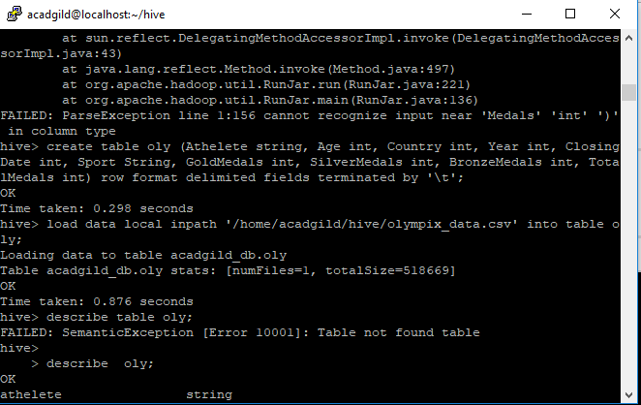

1. Number of medals won by each country in swimming.

SELECT country, sport, count(*) from oly GROUP BY country, sport having sport=’Swimming’;

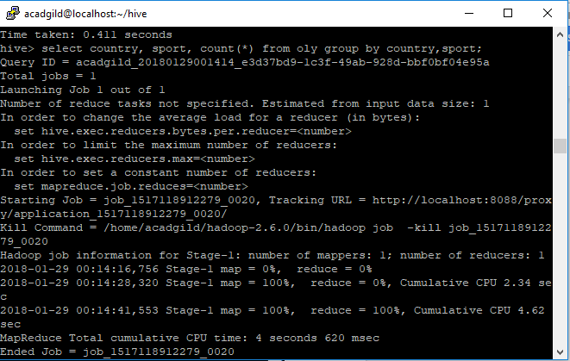

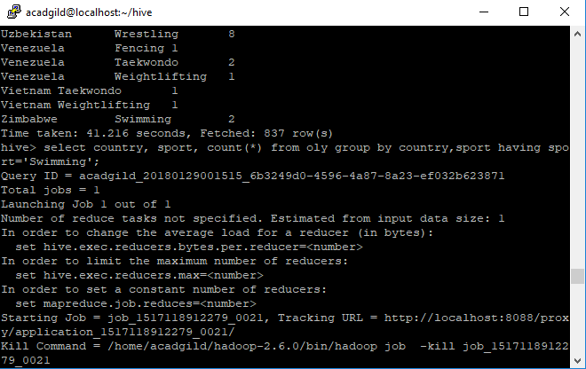

2. Number of medals that India won year wise.

SELECT country, year, count(*) from oly GROUP BY country, year having country=’India’;

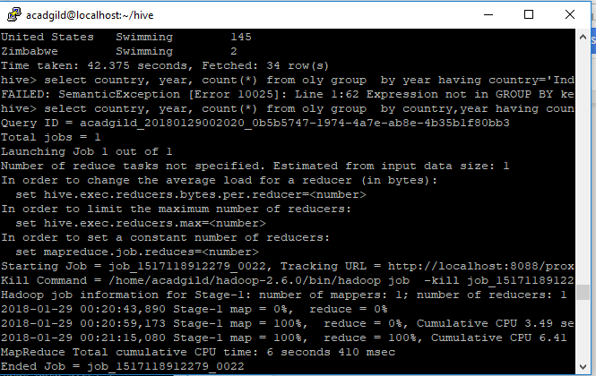

3. Total number of medals each country won.

SELECT country, totalmedals, count(*) from oly GROUP BY country;

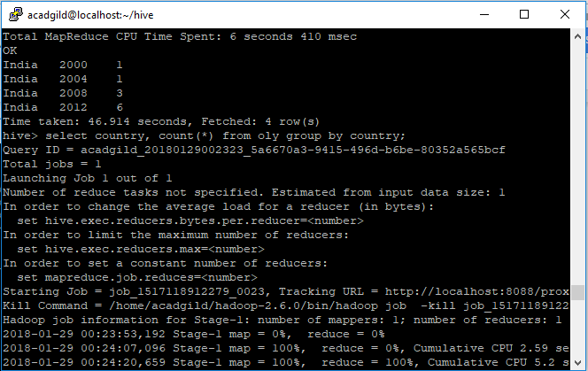

4. Number of gold medals each country won.

SELECT country, count(GoldMedals) from oly GROUP BY country;

